DIFFERENCES OF DATA IN THE ORIGINAL NETCDF FILE (filter_ta.nc), THE CONVERTED_PRESSURE LEVELS_NETCDF FILE (ta4.nc)& THE GRIB FILE (ta5.grb)
filter_ta.nc - level1 | tas4.nc - level1 | tas5.grb - level1
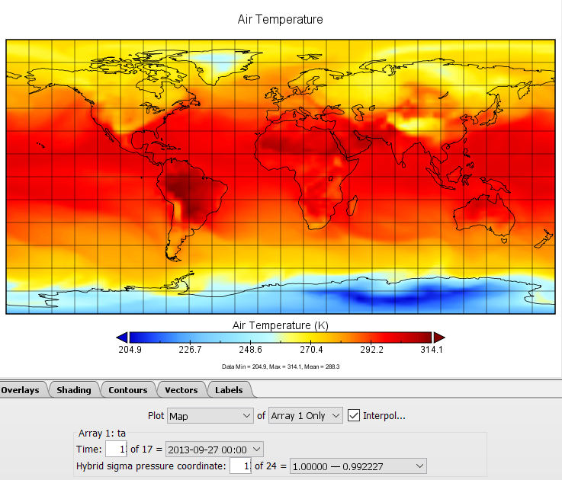 | 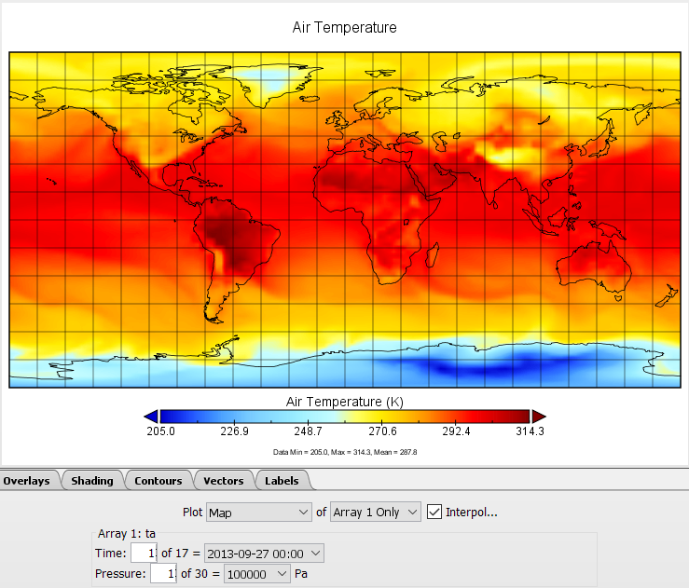 | 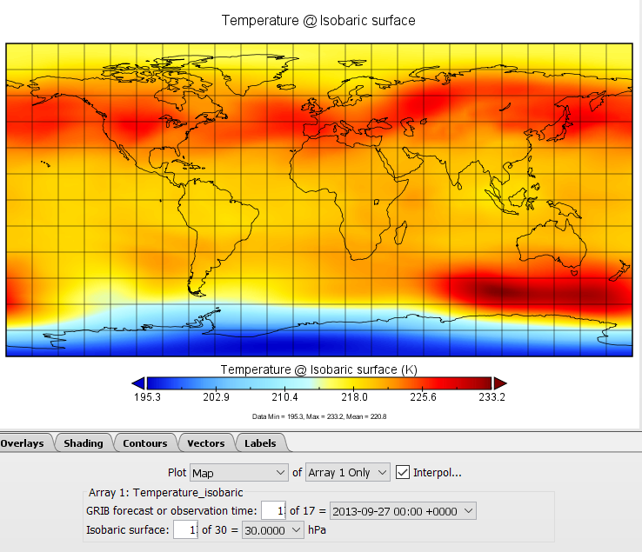
filter_ta.nc – level 24 | tas4.nc– level30 | tas5.grb - level30
 |  | 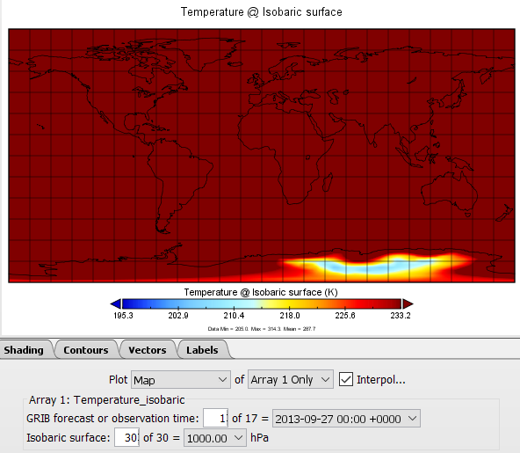
Link of data files:
http://www.mediafire.com/file/v8v2zq5gpo0w2mu/filter_ta.nc/file
http://www.mediafire.com/file/xek5996ubj8u4tx/ta4.nc/file
http://www.mediafire.com/file/iiubaeglx19cky9/ta5.grb/file

STEPS TO OBTAIN THE GRIB FILE

Extract data in wanted time range
cdo -seltimestep,3996/4012 ta_6hrLev_GFDL-ESM2M_rcp45_r1i1p1_2011010100-2015123123.nc filter_ta.nc
- Change time unit from “days” to “hours”
cdo -settunits,hours filter_ta.nc ta0.nc

Invert the height levels
cdo invertlev ta0.nc ta1.nc

Find out the surface pressure
ncdump -v p0 filter_ta.nc | grep "p0 ="
p0 = 101325;

Obtain the hybrid level coefficient

Create a Z-axis description file (myzaxisinvert.dat)
zaxistype = hybrid
size = 24
levels = 1 2 3 4 5 6 7 8 9 10 11 12 13 14 15 16 17 18 19 20 21 22 23 24
vctsize = 50
vct = 100.000000 903.446472 3474.794189 7505.555664 12787.243164 19111.369141 21854.927734 22884.187500 22776.306641 21716.160156 20073.296875 18110.511719 16004.783203 13877.625000 11812.544922 9865.883789 8073.972656 6458.083496 5027.989746 3784.608398 2722.008545 1828.975220 1090.239624 487.459503 0.000000
0.000000 0.000000 0.000000 0.000000 0.000000 0.000000 0.043568 0.110228 0.192225 0.281766 0.369500 0.453235 0.531625 0.603873 0.669556 0.728518 0.780802 0.826599 0.866215 0.900041 0.928536 0.952214 0.971625 0.987352 1.000000

Set z-axis info
cdo setzaxis,myzaxisinvert.dat ta1.nc ta2.nc

Interpolate to pressure levels
export EXTRAPOLATE=1
cdo ml2pl,100000,97500,95000,92500,90000,87500,85000,82500,80000,77500,75000,70000,65000,60000,55000,50000,45000,40000,35000,30000,25000,22500,20000,17500,15000,12500,10000,7000,5000,3000 -selname,ta ta2.nc ta3.nc
- Delete unused variables
cdo delname,ps ta3.nc ta4.nc

Convert NetCDF to GRIB
$ cdo -b 16 -f grb setmissval,0 -chparam,-1,11 ta4.nc ta5.grb

$ cdo sinfo ta5.grb
File format : GRIB
-1 : Institut Source Ttype Levels Num Points Num Dtype : Parameter ID
1 : unknown unknown instant 30 1 12960 1 P16 : 11
Grid coordinates :
1 : lonlat : points=12960 (144x90)
lon : 1.25 to 358.75 by 2.5 degrees_east circular
lat : -89.494 to 89.494 by 2.0111 degrees_north
Vertical coordinates :
1 : pressure : levels=30
lev : 100000 to 3000 Pa
Time coordinate : unlimited steps
YYYY-MM-DD hh:mm:ss YYYY-MM-DD hh:mm:ss YYYY-MM-DD hh:mm:ss YYYY-MM-DD hh:mm:ss
2013-09-27 00:00:00 2013-09-27 06:00:00 2013-09-27 12:00:00 2013-09-27 18:00:00
2013-09-28 00:00:00 2013-09-28 06:00:00 2013-09-28 12:00:00 2013-09-28 18:00:00
2013-09-29 00:00:00 2013-09-29 06:00:00 2013-09-29 12:00:00 2013-09-29 18:00:00
2013-09-30 00:00:00 2013-09-30 06:00:00 2013-09-30 12:00:00 2013-09-30 18:00:00
2013-10-01 00:00:00

